# Title: Business Plan Report Of Tech Solutions

**Tech solutions**

Company logo



**Name: Jafor Ahmmed**

**Batch:60**

**Roll: 10**

**Date: 05-02-25**

**Contents**

1. Executive Summary : 2

1.1 **Company Overview** 2

**1.2****Vision and Mission** 2

**1.3** Market **Position** 2

1.4 **Strategic Goals** 2

1.5 Leadership Team Led by Saikot Anam and a team of seasoned executives, Tech Solutions combines technical expertise and visionary leadership to drive industry transformation. 3

2. Products and Services : 3

1.6 Products: 3

1.7 3

1.7.1 Laptops: 3

1.8 3

1.8.1 Desktops: 3

1.8.2 Tablets: 4

1.8.3 Smartphones: 4

1.8.4 Services: 5

3. Business Plan 5

1.9 Market Analysis 5

1.9.1 Target Market: 6

1.10 Marketing and Sales Strategy 6

1.10.1 Awareness Campaigns: 6

1.10.2 Partnerships: 6

Pricing Model 6

1.10.3 Sales Channels: 6

1.11 7

1.11.1 Team: 7

4. Sales and Cost Statistics 7

# **Executive Summary:**

## **Company Overview**

Tech Solutions is a leading technology company specializing in [primary focus or industry, e.g., software development, cloud computing, AI solutions]. Founded in [year], the company has consistently delivered innovative solutions to [target audience, e.g., businesses, consumers, government sectors], revolutionizing the way [specific impact, e.g., data is managed, services are delivered].

## **Vision and Mission**

Our vision is to [long-term goal, e.g., "empower businesses to achieve unparalleled efficiency through technology"]. Our mission is to deliver [key products/services] that [specific objective, e.g., simplify processes, enhance user experience, drive sustainability]

## **Market Position**

Tech Solutions operates at the forefront of the [specific industry or niche] industry, with a market presence in [regions]. Our competitive edge lies in [key strengths, e.g., cutting-edge technology, exceptional talent, strategic partnerships].

.

## **Strategic Goals**

Expand market presence in [target markets].

Invest in [specific area, e.g., research and development, talent acquisition].

Enhance sustainability efforts by [specific action].

Leadership Team

Led by Saikot Anam and a team of seasoned executives, Tech Solutions combines technical expertise and visionary leadership to drive industry transformation.

Tech Solutions is poised for continued success, leveraging innovation, customer focus, and a commitment to excellence to shape the future of [industry or focus area].

# Products and Services :

## Products:

### 

### Laptops:

High-performance [laptops](https://www.nytimes.com/wirecutter/reviews/best-laptops/) designed for productivity, gaming, and entertainment, featuring the latest processors and sleek designs.

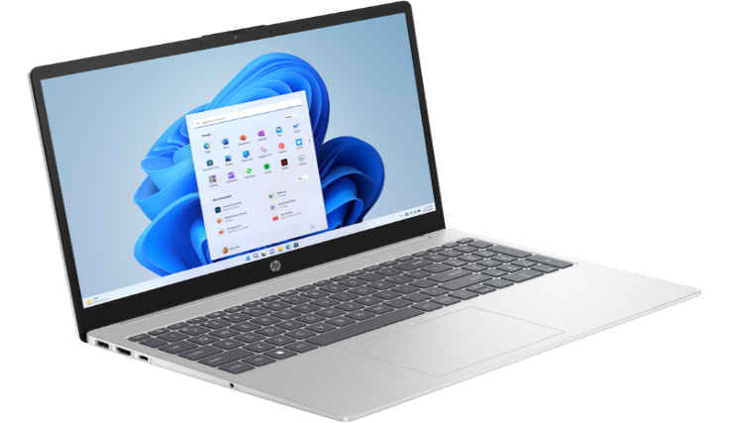

## 

### Desktops:

Versatile [desktops](https://www.nytimes.com/wirecutter/reviews/cheap-desktop-pcs/) tailored for professional and personal use, offering powerful configurations and customizable options.

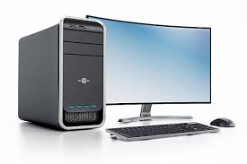

### Tablets:

Lightweight and portable [tablets](https://www.nytimes.com/wirecutter/reviews/best-tablets/) with vibrant displays and multitasking capabilities, ideal for work, learning, and entertainment.

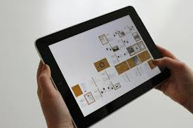

### Smartphones:

Feature-rich [smartphones](https://www.nytimes.com/wirecutter/reviews/best-smartphones/) with advanced cameras, long-lasting batteries, and seamless connectivity for everyday needs

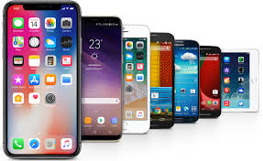

### Services:

* **Warranty and Support:** Comprehensive product warranties and 24/7 customer support for troubleshooting and repairs.
* **Customization:** Personalized device configurations to suit individual and business needs.
* **Software Updates:** Regular updates to enhance performance, security, and device features.
* **Recycling Program:** Environmentally friendly recycling services for old or unused devices

# Business Plan

## Market Analysis

**No**

**Customer from US**

**Process new customer record**

**Submit to controller for approval**

**No**

**Yes**

**Process order**

**Input Order**

**Input Order Info System**

**Purchase order received**

**Current Customer**

**Yes**

Many businesses face challenges in adopting modern technology due to limited resources and technical expertise.

### Target Market:

* local government agencies looking to digitize Small and medium enterprises (SMEs) in retail, manufacturing, and services.
* Educational institutions and operations.

## Marketing and Sales Strategy

### **Awareness Campaigns:**

* Organizing works: shops and webinars to educate businesses about the bengns:**its of technology adoption.
* Digital marketing through social media and local online platforms.

### **Partnerships:**

* Collaborating with local business associations and chambers of commerce.
* Partnering with educational institutions to introduce technology solutions.

Pricing Model**:**

* + **Subscription-Based Pricing:** Flexible plans for SMEs, starting at an affordable rate.
  + **One-Time License:** For institutions seeking long-term solutions.

### **Sales Channels:**

* + Direct sales through our in-house team.
  + Online platform for self-service subscriptions.

## 

### **Team:**

* Software Developers
* IT Consultants
* Marketing and Sales Professional

# Sales and Cost Statistics

|  |  |  |  |
| --- | --- | --- | --- |
| **Product** | **Quantity** | **Cost** | **Sales** |
| Laptop | 5 | 70,000 | 350,000 |
| Desktop | 3 | 50,000 | 150,000 |
| Tablet | 5 | 20,000 | 100,000 |
| Smart Phone | 10 | 80,000 | 800,000 |

# Mission

To empower individuals and businesses with smarter technology solutions by delivering high-

quality products and exceptional services tailored to the needs of a fast-evolving digital world.

# Vision

To be a trusted global leader in the IT industry, fostering innovation, sustainability, and

customer satisfaction through cutting-edge technology.

# Core Values

• Innovation: Embrace emerging technologies to deliver forward-thinking solutions.

• Customer-Centricity: Prioritize customer needs and satisfaction in every interaction.

• Sustainability: Promote eco-friendly practices and products to reduce environmental

impact.

• Integrity: Build trust through transparency and ethical business practices.